Possible types of material

- Photos
  - Subjects
    - People (consent form is required)
    - Objects
      - Statues, ritual implements, etc. (indoor, outdoor, 360)
      - Texts (indoor)
      - Shrines (indoor, outdoor)
      - Cliffs (outdoor)
      - Caves (indoor)
      - Stone inscriptions (indoor, outdoor)
      - Buildings (indoor, outdoor)
      - Context (combining multiple objects)
  - Special Techniques
    - Lighting
      - Flash (if permitted)
      - Side illumination (for reliefs/inscriptions)*see below
    - 360 degree (best with diffuse light)
      - Exterior (landscape etc.)
      - Exterior of object
    - Panoramic

- Videos (consent form is required)
  - Ceremonies / rituals
  - ‘making of’/ project promotion
  - Conversations with key individuals
  - How-to/training/examples of techniques
  - 360 videos

- Audio
  - Conversations (consent form is required)
  - ‘other sounds’/ambient

- Maps
  - Sketches
  - GPS coordinates/tracks

To photograph stone inscriptions, it is recommended to use a lighting source coming from the side:
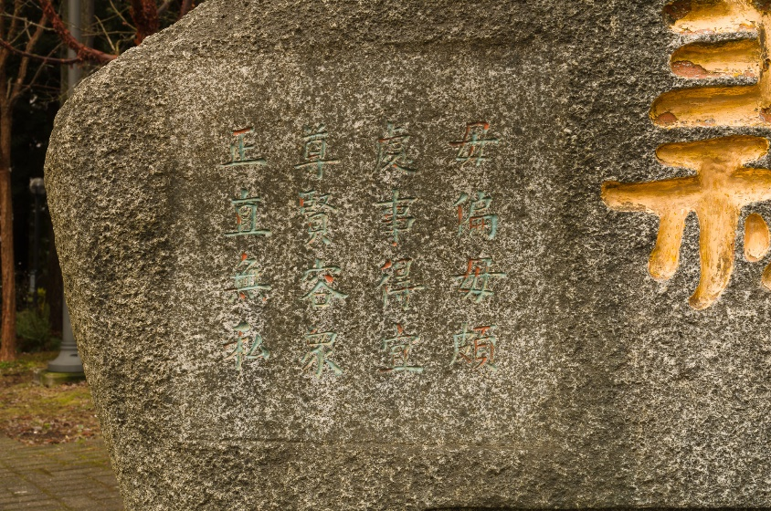
Figure 1: direct photo with no lighting
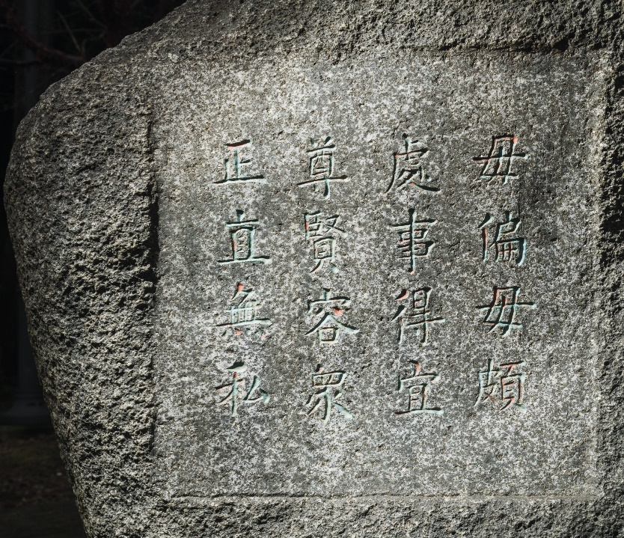
Figure 2: illuminated from side

